Website Inspection Report Using Developer Tools

Evaluator: Teddy Oluoch  
Date: May 14, 2025  
Tools Used: Google Chrome Developer Tools

1. Website: <https://www.bbc.com>

HTML Structure:

Semantic elements used well: <header>, <nav>, <main>, <article>, <footer>.

Repeated use of <div>s with descriptive class names.

Some <img> tags lacked descriptive alt attributes.

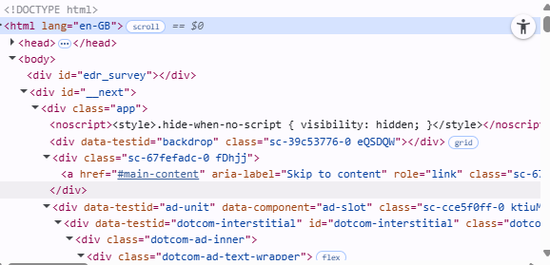

CSS Properties:

Uses media queries for responsive design.

Heavy use of utility classes (.gs-u-display-none, .gel-layout).

rem units used for consistent typography.

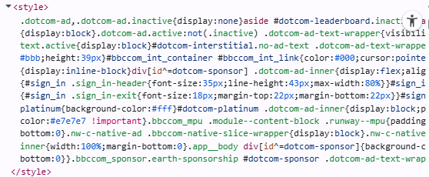

⚙️ JavaScript Console:

No major errors, but a few deprecation warnings related to cookie attributes.

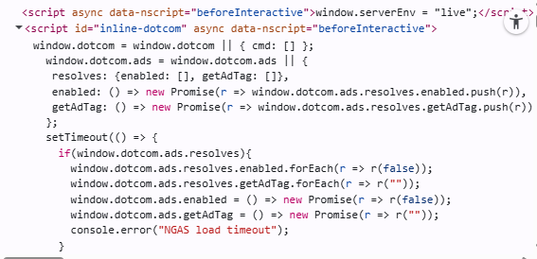

Network Analysis:

Load cookies – 6.62s

Many third-party requests (analytics, ads).

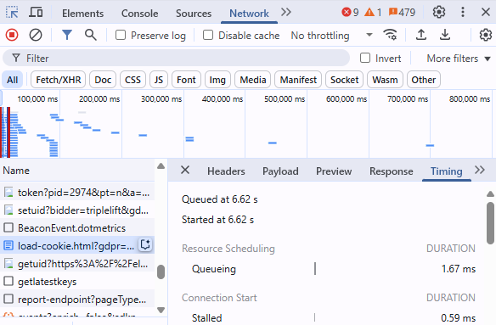

2. Website: <https://www.airbnb.com>

HTML Structure:

Mostly dynamic rendering with JavaScript.

Uses <main>, <section>, <nav> correctly.

Many ARIA attributes used for accessibility.

CSS Properties:

Custom design system in use, well-named utility classes.

Shadows and transitions for a smooth UI experience.

CSS Grid and Flexbox used for layout.

JavaScript Console:

One third-party script warning from a tracking pixel.

No visible runtime errors.

Network Analysis:

Initial load ~5.1 seconds (due to image-rich content).

Effective use of CDNs and code splitting.

Deferred JS loading in place.

🌐 3. Website: https://www.moh.go.ke *(Kenya Ministry of Health)*

HTML Structure:

Minimal use of semantic HTML; overuse of <div> and <span>.

No <main> or <article> found.

Missing lang attribute on <html>.

CSS Properties:

Static stylesheets, some inline styles.

Basic layout using floats and fixed widths (not fully responsive).

Color contrast issues noted on links.

JavaScript Console:

Multiple errors and 404s from missing JS files.

Deprecated document.write() found in one script.

🌐 Network Analysis:

Page load time ~7.8 seconds (slow).

No compression (GZIP or Brotli) on assets.

Poor caching headers.